PNM PRAC Spring 2024 Meeting
March 11, 2024, 1:00PM to 3:00PM
PNM Headquarters / Online Meeting

PNM Attendees: Heidi Pitts, Stella Chan, Stacey Goodwin, Debrea Terwilliger, Thomas Duane, Brent Heffington, Mike Settlage, Laurie Williams, Kelsey Martinez, Cindy Menhorn (MCR), Ian MacDougall (MCR), Nick Phillips (Atrium Economics)

PRC Staff: Bamadou Ouattara, Evan Evans, Georgette Ramie, Christopher Dunn, Elisha Leyba-Tercero, Edison Jimenez

ABCWUA Attendees: Andy Harriger, Keith Herrmann, Jon Ebia, Dwight Velarde

NM AREA Attendees: Peter Gould, Kelly Gould, Jim Dauphinais, Brian Andrews

Attorney General’s Office Attendees: Doug Gegax, Jocelyn Barrett

REIA-NM Attendees: Jim DesJardins

Other Attendees: Barbara Chatterjee (Private Customer), Owen Smith (Meta), Steve Chriss (Walmart), Ann Lyn Hall (Prosperity Works), Marah deMeule (Bernalillo County), Chris Leger (Interwest)

Agenda

- Welcome and roll call
- Review purpose
- Review and participative discussion of proposals
  - PNM - Why PNM thinks there is a need to change
  - NM AREA - Review counter proposal
  - Staff - Review comments
  - Others - Discussion
- Next Steps
  - Allocation method
  - Meetings
  - Other topics for PRAC
- Next PNM rate case

Recording

Link: Save-the-Date Spring PRAC meeting (on-line)-20240311 2019-1

Password: 3sZJYwh3

Minutes

Introduction and Purpose Review

- Stella Chan: As a reminder, PNM feels that it is time to move away from our traditional 3 summer, 1 winter production allocation to reflect the increased renewable resources on our system. PNM went over our proposal in December. Parties have had an opportunity to ask questions on that proposal and we have answered those questions. This meeting is not for us to go over our proposal, but for other parties to go over their comments and proposals.
- Mike Settlage: Historically, the gross peak happened at 5pm in the summertime. Before renewables, this was when our fossil fueled, controllable resources were doing the max. If we didn’t have enough load to cover that 5pm peak, we needed to add more to our resource plan to take care of that. Now, we are moving to an era with renewable resources, which are not dispatchable. That means we must operate our system around the load. At 5pm, there are still a lot of renewables in use that we can’t control. We can control these legacy units to get back down. So, we now have a good bit of reserve capacity at our old peak of 5pm.
- Mike Settlage: Our new problem is roughly at sunset when our renewable resources decrease in production and lighting load is going up. This is what is now driving the cost of additions.
- Evan Evans: Are you saying that your gross peak will not be in the 4-6pm timeframe?
  - Mike Settlage: The gross peak remains the same, but the net peak will be what matters and that will be later on when the sun goes down.

NM AREA Proposal – Jim Dauphinais

- NM Area appreciates PNM’s work on this proposal. NM AREA is open to a much simpler process as this proposal is very involved. We have a lot of modifications in this proposal and it will be difficult to get intervenors hearing examiners up to speed on this proposal.
- We do not feel that PNM’s proposal is not consistent with cost causation completely. We estimate a $10MM inappropriate annual shift of production costs from smaller customers to larger customers in PNM’s proposal. Our modifications address this concern.
- PNM’s modifications to the handling of renewable production costs
  - NM AREA is pleased that this includes a component that reflects the capacity value of renewables that helps to reduce how much non-renewable capacity is needed. That is a positive aspect of PNM’s proposal.
  - NM AREA proposes that any energy shaved off for charging should not be allocated based on a renewable production allocator but should be recovered in the non-renewable energy allocator. That energy is put directly into storage which will be deployed predominantly when non-renewable energy production is necessary.
  - NM AREA proposes that excess renewable energy beyond what is needed for charging and to serve load should also be recovered in the non-renewable production costs allocator. That energy is where system sales margins are going to be associated.
  - NM AREA has concerns that this allocator will struggle to fully conform to Section 62.16.7.B.3.
  - Special service contracts with battery storage agreements need to come into this calculation, specifically in the gross load number. When charging, that’s going to cause more renewables to be taken by that customer and vice versa.
  - It is not clear how that would be implemented in rates. Would it be a reworking of the existing renewable energy rider or brought into the FPPCAC with the possibility of two different class allocators.
- PNM’s modifications to the handling of non-renewable production costs
  - NM AREA is concerned about energy storage agreement costs being placed in non-renewable production costs because there may be energy charges in those agreements. The structure of the contract should not determine how the costs are allocated, but rather cost causation.
  - It is also not clear how this will be implemented much like the renewable production costs.
- PNM’s modifications to the handling with non-renewable fixed production costs
  - It is not reasonable for sunk production costs (decided on before the Energy Transition Act) to be allocated based on the new loss of load hours. They should continue to be allocated based on system peak demand. These sunk costs are not affected by the loss of load hours. This is a unique situation that requires sunk costs to be treated differently from new costs of the same type.
- NM AREA has calculated impact to classes that contain NM AREA customers with both PNM’s proposal and NM AREA’s proposal. This is the same information that PNM shared, only with more granularity with the larger classes. The large shift for large classes, specifically 36B, is caused primarily by the sunk production costs.

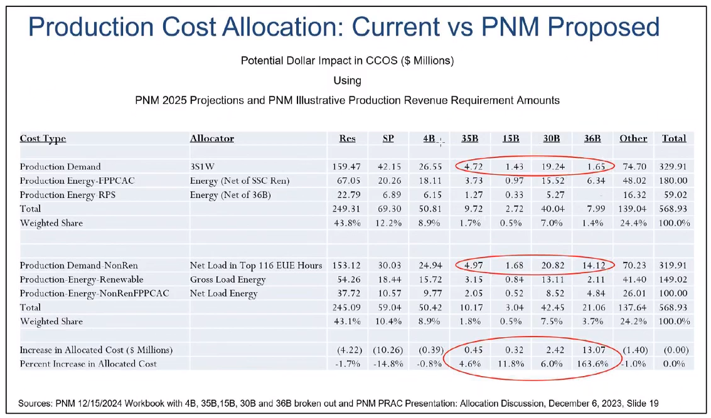

- NM AREA did a second calculation with its modifications to PNM’s proposal. They implemented all the adjustments for renewable allocators discussed earlier and added a new allocator for the sunk “legacy” fixed production costs. We assumed 30% of the non-renewable fixed costs were not legacy costs.
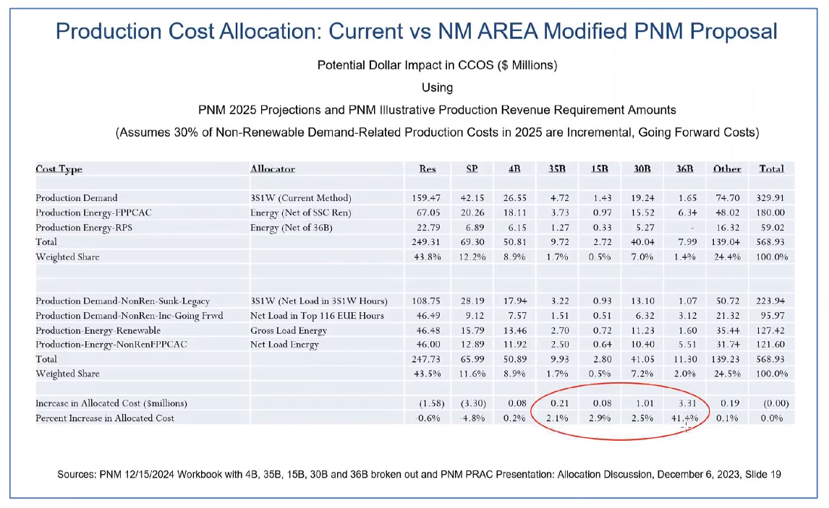

- Mike Settlage: Our silence during your proposal is not meant to convey 100% agreement with the proposal, though we do agree with a lot of that. Our intention today is to have the other proposals to be fully explained and we can debate these proposals at a later date.

PRC Staff Comments on PNM’s Proposal – Evan Evans

- Staff does not have a recommended proposal, but rather concerns and comments on PNM’s proposal. Staff bears the burden of representing the public interest and we want to balance the concerns of all parties.
- Historically, traditional thermal generation represented the vast majority of PNM’s resources. These served all hours and were dispatchable. PNM’s increasing reliance on renewable resources will not operate during all hours. The characteristics of dispatchable resources will change but will still be required to respond to load changes during all hours. However, customer load patterns will not change.
- Rate stability must be maintained. Existing customers should not be significantly adversely affected by unexpected changes in cost allocation or rate design that are not the result of customer loads or usage patterns.
- Staff concerns with PNM’s proposed renewable production capacity allocation method
  - PNM plans and constructs portfolio resources as a single system to meet the needs of customers during all hours. Two separate allocators (renewable and non-renewable) appear to reflect that PNM expects to plan and operate two separate and distinct generating systems.
  - This is a significant change that will significantly impact costs to serve various classes and could significantly impact rates while PNM’s existing rates already produce a very wide range of RORs by class.
  - PNM’s proposed renewable production capacity cost allocator will cause those costs to be allocated by a weighted energy allocator. However, these are capacity or fixed costs that do not vary with the energy consumed by classes.
  - The use of hourly loads for all classes will significantly increase the need for accurate load research data for all classes. This would increase the requirement for PNM to prove the accuracy of their load research data and will increase the effort required for all parties to verify the accuracy.
- Staff concerns with PNM’s proposed non-renewable production cost allocation method
  - Staff’s concerns are again that PNM has constructed a single system, and two allocation methods reflect plans to operate 2 separate and distinct systems.
  - PNM’s proposed allocator is heavily dependent on the 7pm to 8pm time frame, very different from the current allocator. This is expected to have a significant impact on various customer classes, which will impact the stability of rates as they move to full costs.
  - Staff is concerned that PNM’s proposal erroneously conflates loads with resources. A generation resource not only operates to serve on-system native loads but are also used to generate power for off-system sales and PNM must maintain operating reserves in all hours.
  - Staff is concerned that this change will be amplified by the acceleration of cost depreciation of non-renewables due to the Energy Transition Act. The accelerated depreciation will be allocated in a different manner than the costs were allocated previously.
  - Traditional thermal generation also provides rotating mass during all hours, necessary to maintain frequency stability. Focusing the allocation of these loads only when the EUE is the highest does not reflect that this generation will be operating or available during all hours.
  - Again, Staff is concerned with the increased need for accurate load research data and the effort required by all parties to verify that data.
- Staff concerns with PNM’s proposed renewable energy allocation method
  - Staff’s concerns echo our prior concerns that it is allocating only on specific hours rather than all the hours it will be used.
- Staff recommends that allocators be based on customer loads and usage, not driven by the limitations and operating characteristics of generation technology.
- It is important to balance cost allocation methods with the impact on customer classes.
- At this time, Staff cannot support PNM’s proposal.

Other Proposals

- Stella Chan: Does anyone else have any feedback or comments on PNM’s proposal?
- Mike Settlage: Hearing now, we want to say that we appreciate the feedback so far because we want to ensure our proposal meets with the standard rate-making principles of cost causation, gradualism, etc. We are all trying to accomplish the same thing. We’re just not sure how we’re getting there yet.
- Stella Chan: The PRAC’s purpose is to work out these pricing issues prior to filings, so we can have a proposal supported by multiple parties. PNM’s next rate case is planned in June 2024. It is our intention to work through this issue with the PRAC and we still have work to do while meeting the June filing deadline. The hearing examiner has recommended a separate proceeding to deal with rate design and allocation issues, so there will be time for the PRAC to come to an agreement or understanding of this proposed method while still being able to file in June. Should we pursue this two-phase approach, allowing PNM to file revenue requirement in June while giving the PRAC time to work through allocation and rate design in a later filing?
- Jim Dauphinais: This is the first time I’ve considered that suggestion. If bifurcated, do you want to change when the rates go in effect? If not, what’s the purpose of the bifurcation?
  - Stella Chan: It’s a chance for the PRAC to discuss this proposal further and come up with a compromised proposal that will please most parties. The reason for bifurcation would be phase one would approve a revenue requirement using the same, or almost the same, rate design as currently approved. Then, after those rates are implemented, we can have a second hearing just on revenue allocation and modern rate design using the already approve revenue requirement.
- Doug Gegax: After the first phase, then rates would be increased proportionally to what the class revenue increase was?
  - Stella Chan: That is one way to do that, but first we want to know if anybody supports this. And then we can discuss exactly how it would work.
- Doug Gegax: Would the first phase use a cost of service study or banding?
  - Stella Chan: Phase one would use the same allocation methodology as our prior case. As for banding, our status quo is very big range. We would need to look at that and talk about it.
  - Mike Settlage: The idea is not to make more work. We’re not trying to do two rate cases, but rather one rate case in two parts.
- Elisha Leyba-Tercero: I’d like to take the bifurcation concept back to other members of Staff. I see the value in it, but I also see the possibility of the PRAC failing to resolve these issues. Then, you would have essentially two complex and controversial cases. Given Staff’s workload, turning one case into two is not ideal.
- Georgette Rami: I agree with Elisha. It doesn’t seem that the current proposal is close to being ripe. You might consider two separate filings, instead of a bifurcation. This would give customers a chance to adjust to the change from your most recent case and other changes PNM is currently proposing in other areas than just rate design. Customers are being slammed on their budgets and I think its best to deal with one monster at a time.
  - Stella Chan: So you recommend a revenue requirement filing in June, but what would we do with rate design? Keep it the same?
  - Georgette Rami: Yes, keep it the same because it is just being implemented and customers need to get used to the new rates along with the credits.
- Evan Evans: We will take it back and have more discussion internally at the Commission.
- Stella Chan: We will put out some general thoughts on this bifurcation and people can respond via email to it whether they support, don’t, or take no position.
- Barbara Chatterjee: What information are the customers getting about these issues? What changes can we make on our own that will impact this demand?
  - Stella Chan: So far, we have not done much communication. We talked about a website before on the PRAC. We can discuss doing that, providing transparency on what the PRAC is doing. For other information, we can discuss putting this on the website or a bill insert.
  - Barbara Chatterjee: I don’t think this has to fall on the shoulders of PNM. Maybe it falls to the PRC or other organizations or the news media. The information will have to be technical enough to not whitewash or sweeten the reality. If we don’t want people charging cars at a certain time, people need to hear about that.
  - Mike Settlage: Our time of day pilot is meant to give those signals and we hope all parties can help get this message out. We do have a concern that our messaging note that this 7pm to 8pm time period will be shifting later and later.

Next Steps

- Stella Chan: PNM will write up a bifurcation proposal and send it out with a deadline on hearing back from people. We need to know how to prepare for the June filing. We’ll have something tomorrow to parties and we want a response back by Friday.
  - Kelly Gould: I think NM AREA will need more time than that. We need to talk to our clients, which we will on the 19th. We appreciate PNM is on a tight deadline.
  - Doug Gegax: The AG will put together some comments, but we do have some people out this week.
  - Marah deMeule: Bernalillo County will want the opportunity to visit with the AG office as well before we file.
  - Stella Chan: We will ask for responses by Monday, then.

