PNM PRAC Winter 2023 Meeting
December 6, 2023, 1:00PM to 3:00PM
PNM Headquarters / Online Meeting

PNM Attendees: Heidi Pitts, Stella Chan, Omni Warner, Aaron Nazarian, Adria Padilla, Carey Salaz, Debrea Terwilliger, Aaron Braasch, Abraham Casas, Mike Settlage, Pam Milligan, Kelsey Martinez, Cindy Menhorn (MCR), Ian MacDougall (MCR), Nick Phillips (Atrium Economics), Julie Lieberman (Atrium Economics), and testing

PRC Staff: Bamadou Ouattara, Evan Evans, Georgette Ramie

ABCWUA Attendees: Andy Harriger, Keith Herrmann, Jon Ebia

NM AREA Attendees: Peter Gould, Kelly Gould, Jim Dauphinais, Brian Andrews

Attorney General’s Office Attendees: Doug Gegax

REIA-NM Attendees: Jim DesJardins

Other Attendees: Barbara Chatterjee (Private Customer), Owen Smith (Meta), Cydney Beatles (Western Resources), Edison Jimenez

Agenda

- Review Mission and Goals of the PNM Pricing Advisory Committee (“PRAC”).
  - See the attached draft of the PRAC charter that PNM has developed for this discussion.
- Background
- PNM’s proposed allocation methodology
  - Overview
  - Benefits over current method
  - Alignment to Cost Causation
  - Walkthrough of Example and Results
  - Q&A session for questions from Staff and Intervenors
- Near Term Schedule & Next Steps

Recording

Link: Save-the-Date Winter PRAC meeting-20231206 2005-1 - Webex

Password: 4ZykPn3e

Minutes

Review Mission Goals of the PNM Pricing Advisory Committee (“PRAC”)

- Stella Chan: Thank you for joining us. Our goal today is for Mike to go over the materials and answer any questions if possible. We are working closely with our IRP group to come up with our allocation methodologies. PNM is committed to the PRAC process and so we feel it is important to have a charter we can all agree on. Please look at the provided charter and provide feedback when you have done so. Hopefully you will see that we are serious about the process, we will accept the outcome on the process, and we will hopefully find an agreed upon proposal. We hope everyone will work together, be open-minded, and transparent.
- Mike Settlage: We have a few meeting ground rules.
  - 1. Participants will speak one at a time and refrain from interrupting others.
  - 2. Participants are encouraged to voice questions and comments at any time.
  - 3. Participants will wait to be recognized by the facilitator before speaking or will wait for an open question period. Although, given that we tend not to have a problem with this here, please just speak your questions as they come to mind.
  - 4. Participants will ensure that all members who wish to have an opportunity to speak are afforded the chance to do so.

Background

- Mike Settlage: The energy transition act is why we are doing this. The attached presentation went through the milestones of the transition, obligating us to make these changes by the state of New Mexico. We are required to slowly go carbon free by 2040. Today we will be talking mainly about the Class Cost of Service. Our proposal is to arrive at a cost of service study which determines the revenue requirement that we need to collect from each customer class to serve those customers. The data that we have provided for this meeting is clean data separate from the current rate case that we are in. We are dealing here with Allocation, how much each customer should pay. We need a consistency between how costs are incurred and how revenues are received. We will be proposing to use modeling from our IRP process, which is something we’ve never done before.

PNM’s Proposed Allocation Methodology

- Mike Settlage: For the production functional costs, we will allocate by splitting hourly class gross load into hourly class load served by renewables and hourly class net loads. We identify renewable energy to serve loads to serve as the basis for the allocation of renewable resource costs (both PPA and utility-owned renewables). We want to make a simplifying assumption that renewables will first be allocated to storage costs. Class net loads will serve as the basis for the allocation of fuel and no-renewable purchased power costs. They will also be used to develop a class allocator for non-renewable production-demand related costs using the class contributions to the hours with the highest loss of load risk.
- Evan Evans: What is the basis for assigning 100% of renewable for serving storage?
  - Mike Settlage: From a generalized perspective, when the sun is shining, we can charge the battery and we don’t need to discharge the battery. We will discharge it when the sun is not shining. Our assumption is that there is no charging at night.
  - Kelsey Martinez: Operationally, we don’t know precisely how this will work as we aren’t in this position yet. The best way to model it would be to assume that discharging will only happen at night, but some of our batteries have grid charging capabilities and we could do that. We can also discharge during the day.
  - Nick Phillips: In the simulations near-term, unless there is an extreme reliability issue, we would charge storage during the day and discharge at the net peak periods. We are not assuming 100% is assigned to storage. We just want to ensure that storage costs are covered by renewables.
- Mike Settlage: The benefits of this relevant to the current method is that we will more accurately attribute costs to customer classes and more closely align costs with cost causation. We will have a more predictable method to adapt to the expected changes in the system. We will hopefully incentivize conservation and efficiency in use of the system. Lastly, we can send proper price signals so that usage aligns with system planning and operations. We have separated out our traditional systems and our renewable/deeply decarbonized resources. The former are dispatchable, but the latter are generally not. So, the former needs to respond to the latter’s output. Right now, we’re having a mix of these systems, but we will soon have fully decarbonized resources.
- Mike Settlage: We net our gross loads with our load served by renewables to come up with net loads. The more a class uses of the leftover, the more renewable costs they will pay. When resource planning is developing a portfolio, it will be driven by net load patterns, not gross load patterns. Gross load drove everything in the past, as there were few renewables. Whenever the highest gross load was, that was what we had to plan for. Going forward, with renewables, the gross load is no longer the highest load. As the sun goes down, the gross load will be lower than the sunny “peak,” but there are no longer renewables being used and it is now our net peak. For all practical purposes, which will be sunset, and will shift later as time goes on.
- Evan Evans: You’re comparing resources to loads. Resources within them have requirements for reserves. Would it be reasonable to adjust renewable resources down with your planning reserves to be more consistent with your loads? If you have a 15% planning reserve, then will your renewable resources also need to be adjusted for that?
  - Mike Settlage: The nature of renewable resources doesn’t lend itself to that. We don’t have the ability to change the output of renewables. We can’t make the sun brighter or generate more clouds, for example. Reserves comes from, say, a coal unit with extra capacity that you can ramp up or ramp down as needed.
  - Nick Phillips: The way you calculate a planning reserve margin, which is an accounting paradigm, you start as a loss of load probability metric (1 day in 10 standard is often used). You set your system up to meet that metric. What becomes important is recognizing that you have a defined loss of probability metric that you’re calibrating to. So, the idea of just having a 15% planning reserve margin is kind of meaningless without knowing the underpinnings behind it.
  - Evan Evans: Under that scenario, resources equal loads?
    - Nick Phillips: Yes, but with some cushion. The first MW of solar on the system will contribute more to capacity. As we add more solar, I’ll have more nameplate, but my percentage of reserves will change. But you’re always calibrating to this designed loss of load probability metric. If I stack up my load for all of my different resource types, and those are relative to my risk hours, and I’ve hit my loss of load probability metric point of 0.1 LOLE (and let’s say that’s 2500 perfect MW), then I can say that here is my reserve margin. But the way that reserve margin is calculated is not just taking the percentage. It is based on the attributes of the underlying resources and load patterns of the system designated and tied and calibrated to that measure.
- Mike Settlage: The riskiest times are between 7-9pm in the Summer, not in the middle of the day, as the solar panels stop working and there is minimal storage. In 2040 (with more storage), the most critical time will be early in the morning before the sun rises as the batteries are all almost discharged.
- Nick Phillips: Risks will change over time with renewable penetration. We are required by the ETA to meet these renewable requirements, so the system will react to these requirements. The investments chosen will be the ones that provide the lowest cost for highest output during those risky hours.
- Jim Dauphinais: The shift in loss of load risk, which is very real, is driving the new resources that need to be added. I would caution this discussion because we are using renewables, not traditional resources.
- Mike Settlage: Whatever your views are on coal, it is a very flexible resource. They will not be available in the future. It will change to a more inflexible resource, and we all need to adapt to that, no matter our feelings on the matter. The below chart represents where we are now using sample data and where PNM’s proposal shows things. These numbers are in the model that was sent to PRAC participants. This old method uses just 4 hours out of the entire 8,760 hours in the year to allocate all of the costs.

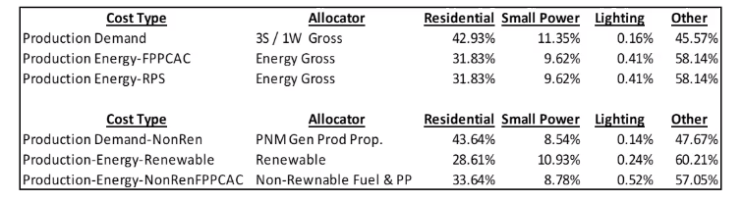

- Mike Settlage: This new methodology below will shift costs to different classes, because those classes use more in the “danger” time periods. Here we will use more hours in the range, about 100-200 hours depending on what methodology we settle on. Don’t be worried about the exact numbers. This is sample data. You can see the difference between the two isn’t that big, except the Other category. We can’t share individual customer data, so that is why we did it this way. Other is all the schedules with very few customers in it. We can provide individual customers specific data if they need it, but we can’t do so in the full presentation.

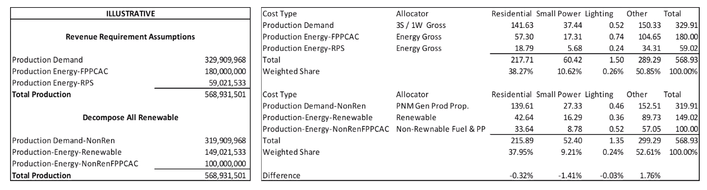

- Evan Evans: As we move forward, will this put more weight on the quality of your load research samples? This will require more staff to develop and to respond to it.
  - Mike Settlage: We have a Grid Mod proceeding that has advanced meters in its proposal. This will give every customer an interval meter, which will take the load off load research. For rate cases, we already need historical hourly loads, so the effort is the same during rate cases anyway.
- Mike Settlage: The below chart is a simple example that shows 3 hours in a made-up day. The first box is the gross load. It shows 3 sample class loads for each hour, and the gross load slowly increases each hour. Based on that, we can come up with a ratio for each of those hours of how much each of these classes is contributing to the whole. That’s the second box, our hourly energy ratio. We multiply those by the amount of renewables left over after we assigned most to storage (the third box). So, the fourth box is the load served to those classes by the renewables. If we subtract that from the gross load, we come up with the class net load, which is the 4th box. We have given everyone an excel file which has the real sample data which uses this methodology for creating net loads. The Class Gross tab has all the raw data necessary to perform calculations for your own analysis.

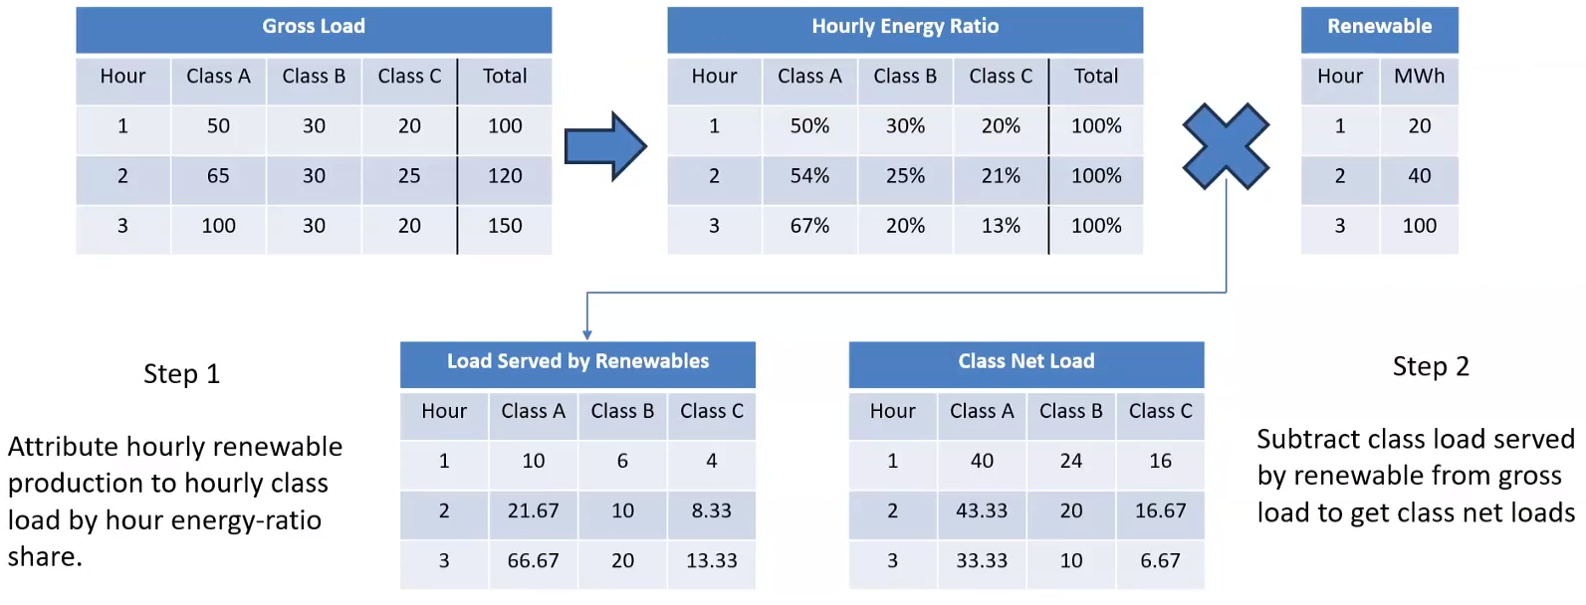

- Mike Settlage: Once we have class net loads by hour, we want to look at the LOLP. So, we take the hours that are most risky and assign those first until we’ve got enough of that risk covered. We then use the total of all those hours to come up with the allocators. All of this is shown in greater detail in the model.
- Nick Phillips: This is what we are seeking feedback on, these two key things. First, how renewable output is spread across classes to generate the net load. Second, how we determine the loss of load risk hours to use in the non-renewable production demand allocation.
- Jim Dauphinais: Our biggest concern is using the proposed non-renewable allocation for conventional resources. They were constructed to meet peak load. Those resources could cover all hours of the year on a dispatch basis. Through their remaining life, they will continue to do that. The new resources are storage or clean resources. The conventional resources should not have a changed allocator. The new resources should, but not the old ones.
  - Mike Settlage: The resources won’t change, but how they are used will be different. It’s also important to look at how customers have caused the costs on the system.
  - Nick Phillips: If you have a set of allocators that isn’t aligned with how the system is actually being used, you’re not recovering costs correctly.
  - Jim Dauphinais: I caution that the costs we are talking about are both fixed and sunk. The energy costs will change, but that’s not changing the sunk costs of the resources. The costs the companies are incurring are the new costs, not the sunk costs, but we shouldn’t overmodulate that by using the sunk costs.
- Peter Gould: Could PNM address the stakeholders access to the modeling? This is modeling driven, and we can’t provide educated responses without the models
  - Mike Settlage: We will provide that data at each stakeholder’s need level.
- Mike Settlage: The below chart is talking about the shift, and I want to focus on the visual on the right. We have overlaid our three summer hours on our heat map. They are June, July, and August, typically in hours 16 through 18. In the winter, it can be later, like hour 18, in the dark. That 1 winter hour has no solar in it whatsoever. The plan has to account for the most stressful time and the current 3S1W does not align to those times. We need to give adequate price signals. We need to discourage EV customers from plugging in as soon as they get home. This will slowly change the gross load as well as the net load over time.

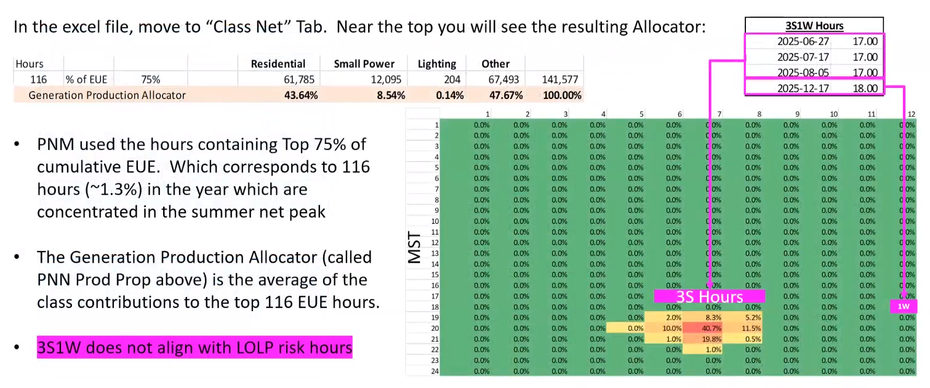

- Nick Phillips: Yes, this will change significantly. By 2040, we expect that almost half the system’s energy and capacity is actually behind the meter. That’s why this will move things so late that the risk will be in the early morning.
- Mike Settlage: The below chart shows how our proposal is different from the current method. Small Power, as an example, has a significant decrease in cost allocation because they are using power at a time when it’s less risky and production costs are lower. Residential does not change much.
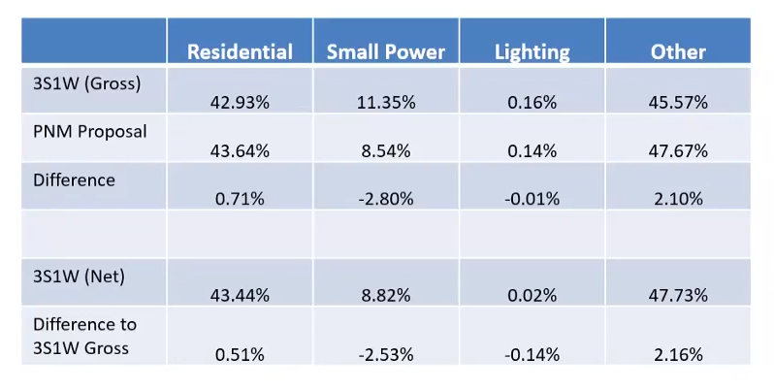
- Jim Dauphinais: The 3S1W is using the gross load dataset. So, it is probably worth noting as the workbook has a 3S1W that is different here.
  - Stella Chan: The one in the workbook reflects the 3S1W in the current rate case, not the sample data we are using here.
- Evan Evans: Are you looking at doing a time-of-day fuel factor to reflect when renewables are used?
  - Mike Settlage: We have a fuel factor that is the same for everyone and the same for every hour. We have not proposed that here, but it may be worth looking into.
  - Nick Phillips: By doing the renewables hourly before looking at non-renewable costs, this would give some benefits of having your load patterns more closely aligned with renewables and getting a greater share of those costs and lesser share of the other costs. It would give an implicit capacity benefit from the renewable.
- Barbara Chatterjee: In the last billing cycle, I saw an ad from PNM suggesting EVs should charge at night. Why are we doing this if they are the risk hours? There seems to be an assumption that the public wouldn’t make those changes if they knew what the need was. There is an educational issue here.
  - Mike Settlage: The goal with our EV rates is that it is a short-term interim solution. We just don’t want everyone to plug in right as the sun was setting (as soon as they get home). We envision changing this overtime to reflect that.
  - Barbara Chatterjee: You should be saying that then. We need to understand that, and it isn’t being communicated conceptually. They will need to make many changes, so it is essential that these issues have a much broader understanding.
    - Mike Settlage: We agree with you.
    - Nick Phillips: The heat maps that we are showing here are capacity heat maps only. This is a multi-objective thing that we are trying to solve here, and we are dealing initially on this one component.
- Barbara Chatterjee: Another factor is if more people work from home, EV charging patterns will change. You should begin to encourage charging while they are at home during the day.
  - Mike Settlage: That is reflected in our proposed TOD rate, which as the off-peak time during the middle of the day to encourage that very thing. We recognize that communication with customers is key, so they understand this. We need to bring people along on this journey and there may be room for improvement in that regard.
- Jim DesJardins: PNM has a huge amount of behind-the-meter solar systems, currently at 41,000 equaling 246 MW. It should triple, according to a presentation given. I’ve not heard about how we can take advantage of those resources via virtual power plants. How can that factor into pricing?
  - Mike Settlage: That’s a complicated question. By having TOD pricing, they will help people choose to store during the sunny hours and discharge when electricity is the most expensive. We are not yet at the point to talk about virtual power plants. We’re just not there yet.
  - Stella Chan: I was going to propose that in January, that same presentation be made so we all understand the impact on our system now and its potential impact. We want to think about how to incentivize customers with DRM and how to recognize the value that they bring to the system. We are also involved in the community solar proceeding, which is a kind of DRM.
  - Jim DesJardins: There are pilot programs in California in effect right now that we can look at and see if we can do something in that area.
  - Mike Settlage: We know that there is value to these systems and, as best we can, we need to make sure we’re giving people compensation for the value provided. It is the opposite of what we are doing here on the load side of things, ensuring that people are charged appropriately. Those two issues go hand-in-hand.

Near Term Schedule & Next Steps

- Stella Chan: Please send us any questions you have on this data. We have received questions from Staff and NM-AREA already and we welcome questions from any parties. We can even set up a call with a party and answer questions that way. We want people to have all the info needed to make an informed decision and complete analysis.
- Doug Gegax: I just want to understand. The excel file is based on the current rate case, correct?
  - Mike Settlage: The data is based on the IRP filing that we are about to file with some timing differences. We can give you whatever dataset you need, though.
- Stella Chan: We will send out another survey so that we can make that presentation in January. It will be about a 15-to-20-minute presentation, but we want discussion afterwards. The survey will have available dates and times.
- Jim Dauphinais: We want to see the presentation. We are thinking that the earliest we can provide written comments is about January 16. We can do that by then. We would also know if we would have an alternative by then. If we do have an alternative, we could present that sometime in March. That is our timeline, but we don’t know others’.
- Cindy Menhorn: Additionally, we want comments on the charter as well.
- Barbara Chatterjee: Can we use this data to analyze how the patterns of home usage are different for those working at home or otherwise? Can you create some quartiles of usage or gross numbers to find patterns geographically?
  - Mike Settlage: That would be difficult as we are looking at the residential class as a whole and we don’t know who works from home.
  - Nick Phillips: Part of the issue is that we have a limited number of sample meters with little demographic information on working from home and such. We would need to wait for AMI deployment for what you are looking for.
  - Barbara Chatterjee: I want to look for patterns for TOD usage going up or down or whether it stays consistent and then see if there are locales or groups. That will help us come up with questions.
  - Cindy Menhorn: We can look for existing load shapes out there from other utilities to see how activity has shifted based on working from home.
- Jim Dauphinais: We will eventually need a dataset not just for now, but for some period 10 years out. If this methodology is only a near term proposal, we can use that data to maybe pick a more robust method on what we expect in the future. That may not be something you can provide now, but it is something that will be needed as this discussion moves forward. It is difficult for us to understand how this works out as we get closer to 2040.
  - Mike Settlage: We will see what we can provide.

